Authors’ Profiles

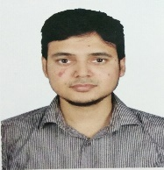

Dr. Md Iftekharul Mobin is an Assistant Professor of the Faculty of Science and Technology at American International University-Bangladesh (AIUB). His research interests are NLP, time-series prediction, health informatics, IoT, Image processing etc. He can be contacted at iftekhar.mobin@aiub.edu



Dr. S. M. HASAN MAHMUD is an Assistant Professor of the Faculty of Science and Technology at American International University-Bangladesh (AIUB). His research interests include machine learning, deep learning, bioinformatics, drug discovery, and pattern recognition. Email address hasan.swe@aiub.edu

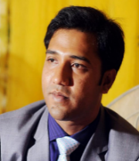Dr. Debajyoti Karmaker is currently working as an Associate Professor of the Faculty of Science and Technology at American International University-Bangladesh (AIUB). His research interests include computer vision, machine learning, and deep learning. I am particularly interested in the areas of object detection, action recognition, and biologically inspired collision avoidance strategies for quadcopters. He can be contacted at d.karmaker@aiub.edu

Ariful Islam has completed his Bachelor's in Computer Science & Engineering and Master's in Information & Database Management from American International University-Bangladesh (AIUB) in 2021 and 2023, respectively. He is interested in research areas including Data Mining, Machine Learning, Data Analytics, Graph Theory, and a wide variety of Algorithms and Data Structures.